UNITED BLACK FUND, INC. HELPING PEOPLE

HELP THEMSELVES
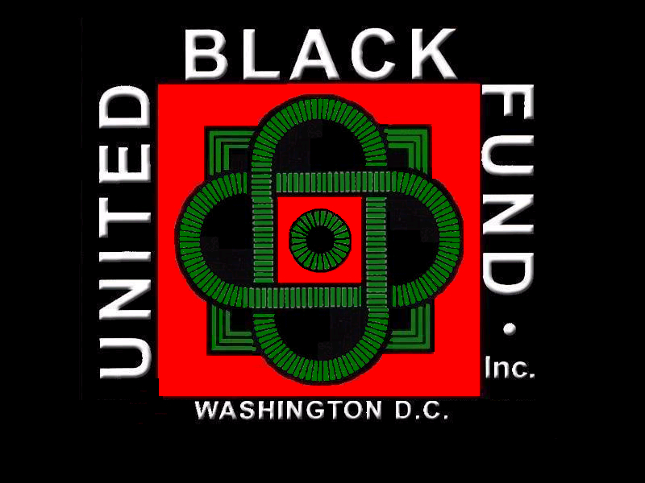

2017 - 2018
ANNUAL REPORT

2524 Pennsylvania Ave. SE
Washington, DC 20020
(202) 783-9300

www.ubfinc.org
unitedblackfund@ubfinc.org

CFCNCA #28836 DC One Fund #8500

United Black Fund, Inc.

2017-2018 ANNUAL REPORT

PROGRAMS

OVERVIEW OF PROGRAMS AND INITIATIVES

United Black Fund completed its 49th year of service working on the challenging and often overwhelming conditions that reduce and diminish Black people, and poor people throughout the Washington, DC Area. We work with more than 52 Non-Profit Organizations.

Our work connects with individual, family and community needs. We target needs that impact youth, young adults, seniors and whole communities. We maintain close ties with everyday people in neighborhoods, schools, parks and other places that define community life. Helping community residents help themselves by assisting in program formation, resource gathering, and participant recruitment are central to our work to improve neighborhood life. Our programs draw on the rich experience of a highly motivated, well-trained and committed staff. We are a part of the community, and we are working to make life better.

In Program Year 2017-2018, UBF conducted 5 major programs and several important events in the Washington Metropolitan Area.

I. Black History Invitational Swim Meet
II. I Love Life Campaign
III. Agency Leadership
IV. Cora Rice PG County Police Christmas Party
V. Ending the Violence Campaign

I. BLACK HISTORY INVITATIONAL SWIM MEET
The Black History Invitational Swim Meet completed its 32th year in 2018. UBF operates this program in partnership with the DC Department of Parks and Recreation, and with the DC Wave Parent Booster Club. Swim Teams from Maryland, Virginia, and from all across the country participate in the Meet. Youth 8 and under to 18 years old, Parents, Swim Team Managers, Coaches, and more than 150 volunteers assemble at the Takoma Aquatic Center in Washington, DC for three days during Black History Month for the competition. The Meet has grown from a small local competition to one now hailed by USA Swimming as the “premier minority swim competition in the United States and the World.”
Competition swimming involves parents and children alike in a rigorous routine of afterschool and weekend practice, practice, practice. The program joins parents, children, government and community. The goals of this program are: to enlist and encourage minority and other youth in a competitive swimming program; to help youth develop swimming skills; to encourage youth to seek Life Guard Certification and employment; to encourage youth to participate in high school swim competitions; to encourage youth to seek college scholarships in swimming; to encourage youth to participate in national swim competitions; and to complete to participate in Olympic Game swim competition. All the values of trying and making your best effort, playing fairly by the rules, listening and learning combine to make this program a model for other youth sports.
This year marks the largest contingent of the event’s history with more than 900 youth from 25 teams participating from the District of Columbia, the island of St. Lucia and 8 states including: Georgia, Maryland, Michigan, New Jersey, New York, Ohio, Pennsylvania and Virginia; in this three-day, highly competitive, national swim meet.
“The Black History Invitational Swim Meet was founded to nourish self-reliance, determination, and the spirit of fair play for youth and parents." said Director Keith Anderson. “The BHISM continuously provides a positive outlet for young competitors. The theme for this year’s event is 'Make A Splash, Be Legendary.'

Dr. Calvin Rolark and Dr. William H. Rumsey founded the BHISM in 1987. During the BHISM, youth athletes, ranging in age from 5 – 18, compete in standard swim events, such as the individual medley, freestyle, butterfly, relays, and back and breast strokes. The BHISM is hailed by USA Swimming (the national governing body for the sport of swimming) as the “Premier minority swim competition in the United States and in the world.”

United Black Fund, Inc. hosted an Honoree’s Dinner on Saturday, February 16, 2018 from 5:30 pm to 8 pm. Invited guests to this year's honoree dinner included: Coach Gary Peterson of the Detroit Recreation Swim Team (DRST), Coach Tommy Jackson of the City of Atlanta Dolphins Swim Team (CAD) and Lee Pitts an internationally renowned swim instructor; Mayor Muriel Bowser, Deputy Mayor Brenda Donald, past BHISM honorees, event partners, sponsors, city officials and dignitaries.

II. I LOVE LIFE CAMPAIGN 2017-2018
The annual Campaign offers DC Public School Students, grades 10-12, the opportunity to express their view of life in essay, poster, speech, or song. Winners receive cash awards and all participants receive I Love Life Certificates for participation. Dr. Marilyn Brown, former Associate Superintendent of Schools, DCPS, Chairs UBF’s Education Committee and plays a central role in the I Love Life Campaign.
The I Love Life Campaign began in 1994 at a time when the incidence of violence rose to apocalyptic levels in Black and poor communities throughout the nation. The incidence of murder and gun violence in the Washington DC area was pandemic, as crack cocaine and other potent cheap drugs flooded into everyday life and “street justice” and muscle enforced territorial boundaries and debt collection. In too many communities school children went to bed and woke up amidst the sounds of violence, loud arguments, screeching tires, gunfire, police and ambulance sirens; and walked to school through the artifacts of mayhem ... Yellow Police Tape, News Teams, sobbing relatives, Teddy Bear and Liquor Bottle Memorials.
In many schools, the learning environment is difficult. Community problems spill into the school environment and, too often, preoccupied or dominated the minds and thoughts of students. Teachers and administrators are expected to manage community turmoil and educated at the same time. The I Love Life Campaign was devised to reduce the level of trauma and apprehension among students, and to help students overcome posttraumatic stress common to everyday life in violent communities and households.

Results 2017 I Love Life Campaign
We trialed this program in DCPR results couldn’t be determined and we anticipate returning the program to public schools in the future.

IV. AGENCY LEADERSHIP PROGRAM
One of United Black Fund’s central missions is to help people organize and operate non-profit corporations. From its inception, UBF worked with small groups and organizations to improve both administrative and operational functions so that program services were more efficiently and effectively delivered. The Agency Leadership Program achieves that purpose.
The fundamental challenge of operating a non-profit corporation combines managing a business with providing a public service. The environment in which non-profits operate grows more technical and competitive daily. There is growing public demand for non-profits to operate in daylight and achieve transparency. Performance and operating standards are rising.
Meanwhile, the process of formation alone can appear so convoluted and confusing that people with terrific ideas and abilities are frustrated away. Assuming a candidate survives formation, the reality of generating resources to implement those ideas that change the world can cause traumatic shock or completely terminate the effort to serve.
Even when start up barriers are successfully hurdled, there will be times when, despite best efforts and practices, help is needed ... sometimes just a little help, and sometimes a little more than a little.
The Agency Leadership Program is an incubation that provides assistance and training in Corporate Formation, IRS 501 © (3) Certification, Program Development, Resource Identification and Fundraising, as well as provides Grants (Above $3,000), Mini Grants ($1,000 to $3,000), and Micro Grants ($1,000 and under).
Participants learn to utilize technical and program support online… like IRS.gov Charities and Non-Profits; Board Cafe; Tech Soup; DC Office of Partnerships and Grants; and other non-profit technical and program support sites.
Corporate Documents, like Articles of Incorporation and Bylaws, and IRS Form 1023 (Application for Recognition of Existence Under 501 © 3) are used a teaching/learning tools.
Workshops for Board Development and other fundamental elements of non-profit structure are conducted utilizing experienced Non-profit leaders. Mentoring by experienced agencies provides additional support for new organizations.
UBF provides and maintains, at no charge, a shared office suite for newly formed agencies. Our goal is to relieve for a limited period of time some of the pressure of having to raise funds for immediate needs. Desk space, Telephone service, Meeting space, and limited use of printing and copy facilities are provided. Agencies are encouraged to “hatch” within 18 months.
On going July-June .

Capacity and Event Support
UBF worked with and provided Capacity support to 14 agencies in various areas of formation and capacity development. We provided event planning and operation support along with supporting funds to 12 agencies for special events.

V. CORA RICE PG COUNTY POLICE CHRISTMAS PARTY
UBF’s “Cora Rice PG County Police Christmas Party” is operated in collaboration with the PG County Police Department, PG County Public School System, PG County Executive, and PG County NAACP, The all day event is held annually at Eleanor Roosevelt High School in Greenbelt, Maryland.
Cora Rice, legendary Community Servant, joined the United Black Fund with the PG County Police Department in an effort to bring Police and Community youth closer together to co-sponsor an annual Christmas party for deserving children to foster improved relations between Police and Community.
Police-Community relations are more important today than before. The Cora Rice PG County Christmas Party gives Police and youth an opportunity to meet and greet in a fun filled atmosphere. Children need to know that Police are real people, and Police need to know that these kids are just like all kids.
The party begins at 9AM in the Roosevelt High lunchroom and continues there until a meal is served around lunchtime. Police in Santa hats and antlers distribute themselves throughout the lunchroom making sure that there are two or three officers at every table. The interaction among kids and police is really something special. More than 100 officers will flow in and out of the party during the course of the day. Lines for Pictures with Santa Claus are continuous throughout the morning. Lunch is served after which the party moves to the Roosevelt auditorium where the PG Police Band and other talent put on a show. Singing and stories and skits set the atmosphere for gift giving. The party ends too soon for most. Everyone leaves with a little bit more of a bigger picture.

2017 Cora Rice PG County Christmas Party
515 children joined with Prince George’s County Executive Rushern Baker, P.G. County Police Chief Mark Magaw, and 120 PG County Police Officers and first responders at the 32nd Annual Party. As they do each year, Officers wore their holiday costumes as Santa’s and Santa helpers set up in 3 classrooms to give each child a chance to convince Santa that they were deserving of holiday gifts. Each child took a picture with one of the three Santa dressed officers. Face painting, art projects, balloon animals, song and dance made for a great holiday celebration.

VI. ENDING THE VIOLENCE CAMPAIGN

A) Program Overview
This is a ten-year initiative begun in 2008, and scheduled to conclude in 2019. This Campaign now has an ongoing timetable…to conclude when community violence ends. The Campaign seeks to stimulate discussion about the causes and solutions to violence, and to nurture interest in developing a public campaign aimed at reducing violence. The program is now extending into Washington area communities where violence is ongoing. We are concentrating on two communities at this time. The Barry Farms and Woodland Terrace Communities have very serious challenges that too often erupt in violence. We are engaging these communities in an effort to reduce and eliminate the incidence of violence.

B) Need Statement
Statistics on violence are horrifying. The reports about shootings or beatings come so regularly and often that we don’t really talk very long about them. The sounds of gunfire, domestic violence, gang fights and killings are regular experiences in the daily lives of too many children. The level of violence promoted in TV, movies, gaming and music reinforces this reality. We are in denial. We have to talk about this problem if we are ever going to do something about it. The talk is done. It’s time to take action to change these conditions

C) Program Summary
Incarcerated persons from Washington, DC are housed in penal institutions all across the country. We expanded our End the Violence Campaign to the 40 most violent areas of the country. We will bring the opportunity to engage this message driven contest to some of 2,500 persons returning to DC from incarceration in those areas. We are engaging two communities where many formerly incarcerated persons return. We will work to engage youth in activities that counter the message of violence. Our goal is to expand this effort to 6 Public Housing Communities across the city.
Last year we identified community partners in our target neighborhoods. We connected with Helping Hands, Inc. and the One DC, both UBF agencies from our Agency Leadership program. We sponsored Helping Hand’s Mother’s Day for the Homeless initiative, their work to provide Clothing to residents. Also had a Mother’s Day dinner for mothers who were victims of domestic violence.
We duplicated our support in One DC, an organization helping young adults obtain jobs through workforce development and training. These young adults age from 20-24 and UBF provided open office space and supplies.

UBF supported the January 16, 2018 MARTIN LUTHER KING, JR. PEACE WALK AND PARADE, sponsored by many community partners. The Peace Walk is an extension of the historic Martin Luther King, Jr. Parade, historically the first commemorative event in the nation to honor Dr. Martin Luther King, Jr. after his death in 1968. The Peace Walk followed the traditional route traveling from the United Black Fund at 2500 Martin Luther King, Jr. Avenue to the RISE Center at Saint Elizabeth Campus. Peace Walkers joined the PARADE… Marching Bands, Step Teams, Cheerleaders, a host of Community Organizations, Businesses and political leaders from all across the area joined in a festive Parade and joy filled tribute to Dr. King.
.

